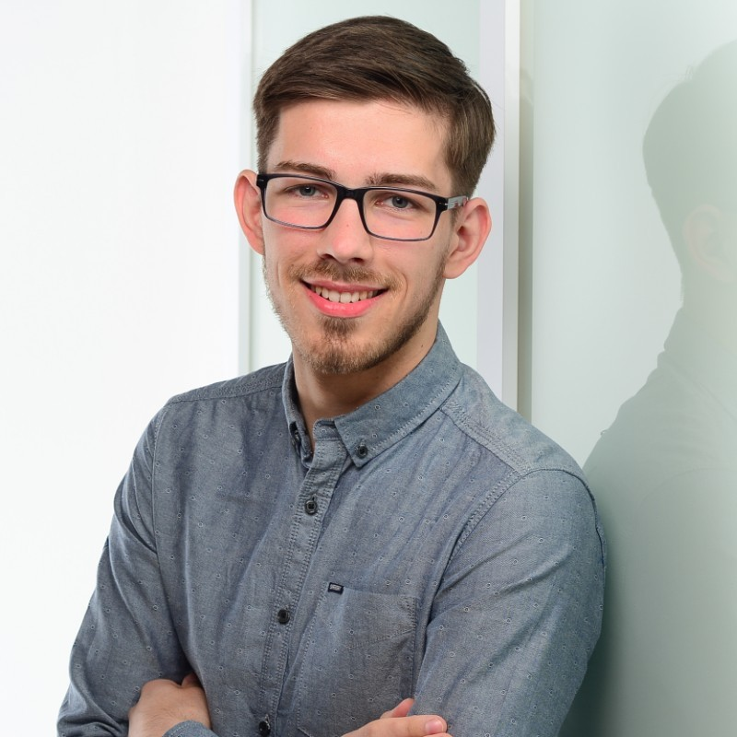

Torben Böttcher
__________________________________________________________________

CONTACT  0172 8026740  torbboettcher@outlook.de Linkedin.com/in/torben-böttcher  ________________________________  EDUCATION  Master - Computer Engineering  Leibniz University Hannover  September 2021  Bachelor - Computer Engineering  Leibniz University Hannover  October 2019  ________________________________  TECHNICAL SKILLS  - Java, Golang, Python  - Software Architecture  - Kubernetes, Helm, Docker  - PostgreSQL, Apache Kafka  - CI/CD, ArgoCD  - API- and Test-driven development  SOFT SKILLS  - Individual Leadership  - Problem Solving  - Knowledge Transfer & Collaboration  - Mentoring & Coaching |  | Skilled Cloud Platform & Backend Engineer with 3+ years of experience building scalable systems and providing technical guidance within teams. Strong expertise in Kubernetes, Java, and Golang, with a proven track record delivering reliable platforms and microservices. Known for combining hands-on engineering with a collaborative mindset, promoting DevOps practices, and mentoring team members to enhance productivity and product delivery.  __________________________________________________________________  PROFESSIONAL EXPERIENCE  Cloud Platform Engineer  SYNAOS - Hannover | | September 2024 –Present  - Developed two Kubernetes operators in Golang to automate platform management tasks.  - Provided individual guidance to three engineers, fostering skill growth and employee satisfaction.  - Led the migration of three platform services (Opensearch, PostgreSQL, Kafka) to cluster-level infrastructure, improving maintainability and scalability.  - Promoted DevOps practices across teams through regular knowledge transfer sessions.  - Improved team productivity through collaborative processes, contributing to the delivery of three product extensions.  Backend Developer  SYNAOS - Hannover | | September 2021 – October 2024  - Designed and implemented a patented traffic management algorithm for mobile robots  - Trained support engineers to support and operate the developed products to reduce developer interaction by up to 100%  - Developed four java microservices using technologies like PostgreSQL, Apache Kafka, REST and GraphQL  - Provided individual guidance to two engineers  Working Student Software Development  SYNAOS - Hannover | | February 2021 – September 2021  - Tested machine learning approaches for travel time estimations of mobile robots during my master thesis

